**Python**

**Answer. 1 Python**

[**https://github.com/shiva4778/Ineuron_ppt_assignment/blob/main/Python_1.ipynb**](https://github.com/shiva4778/Ineuron_ppt_assignment/blob/main/Python_1.ipynb)

**Answer. 2 Python**

[**https://github.com/shiva4778/Ineuron_ppt_assignment/blob/main/Python_2.ipynb**](https://github.com/shiva4778/Ineuron_ppt_assignment/blob/main/Python_2.ipynb)

**Answer. 3 Python**

[**https://github.com/shiva4778/Ineuron_ppt_assignment/blob/main/Python_3.ipynb**](https://github.com/shiva4778/Ineuron_ppt_assignment/blob/main/Python_3.ipynb)

**Answer. 4 Python**

[**https://github.com/shiva4778/Ineuron_ppt_assignment/blob/main/Python_4.ipynb**](https://github.com/shiva4778/Ineuron_ppt_assignment/blob/main/Python_4.ipynb)

**Answer. 5 Python**

[**https://github.com/shiva4778/Ineuron_ppt_assignment/blob/main/Python__5.ipynb**](https://github.com/shiva4778/Ineuron_ppt_assignment/blob/main/Python__5.ipynb)

**Answer. 6 Python**

[**https://github.com/shiva4778/Ineuron_ppt_assignment/blob/main/Python_6.ipynb**](https://github.com/shiva4778/Ineuron_ppt_assignment/blob/main/Python_6.ipynb)

**Answer. 7 Python**

[**https://github.com/shiva4778/Ineuron_ppt_assignment/blob/main/Python_7.ipynb**](https://github.com/shiva4778/Ineuron_ppt_assignment/blob/main/Python_7.ipynb)

**Answer. 8 Python**

[**https://github.com/shiva4778/Ineuron_ppt_assignment/blob/main/Python_8.ipynb**](https://github.com/shiva4778/Ineuron_ppt_assignment/blob/main/Python_8.ipynb)

**Answer. 9 Python**

[**https://github.com/shiva4778/Ineuron_ppt_assignment/blob/main/Python_9.ipynb**](https://github.com/shiva4778/Ineuron_ppt_assignment/blob/main/Python_9.ipynb)

**Answer. 10 Python**

[**https://github.com/shiva4778/Ineuron_ppt_assignment/blob/main/python_10.ipynb**](https://github.com/shiva4778/Ineuron_ppt_assignment/blob/main/python_10.ipynb)

**Statistics**

**Q-1.**

**A university wants to understand the relationship between the SAT scores of itsapplicants and their college GPA. They collect data on 500 students, including their SATscores (out of 1600) and their college GPA (on a 4.0 scale). They find that the correlationcoefficient between SAT scores and college GPA is 0.7. What does this correlation coefficient indicate about the relationship between SAT scores and college GPA?**

**Ans:**

Correlation coefficient of **.7** indicates that there is a strong positive correlation between SAT score

& college GPA. We can say that as the SAT score increases , then college GPA score will also increase.

So, the student those who scored higher in SAT score have a generally higher chance to score higher GPA.

Correlation doesnot imply that change in y is only due to x. This means that while there is the relationship between SAT scores and GPA, it doesnot mean that higher SAT score generally cause the higher GPA. There can be other factor for higher GPA like study habits, higher motivation can also play a good role for achieving good GPA.

**Q-2.**

**Consider a dataset containing the heights (in centimeters) of 1000 individuals. The mean height is 170 cm with a standard deviation of 10 cm. The dataset is approximately normally distributed, and its skewness is approximately zero. Based on this information, answer the following questions:**

**Ans:**

To find the percentage of individuals with heights between 160 cm and 180 cm, we need to calculate the area under the normal distribution curve between these two values.

According to the empirical rule 68% of data will fall between 1 standard deviation , 95% will fall within 2 standard deviation.

Percentage of individuals in the dataset have heights between **160** cm and **180** cm is

We have to calculate the corresponding Z score :

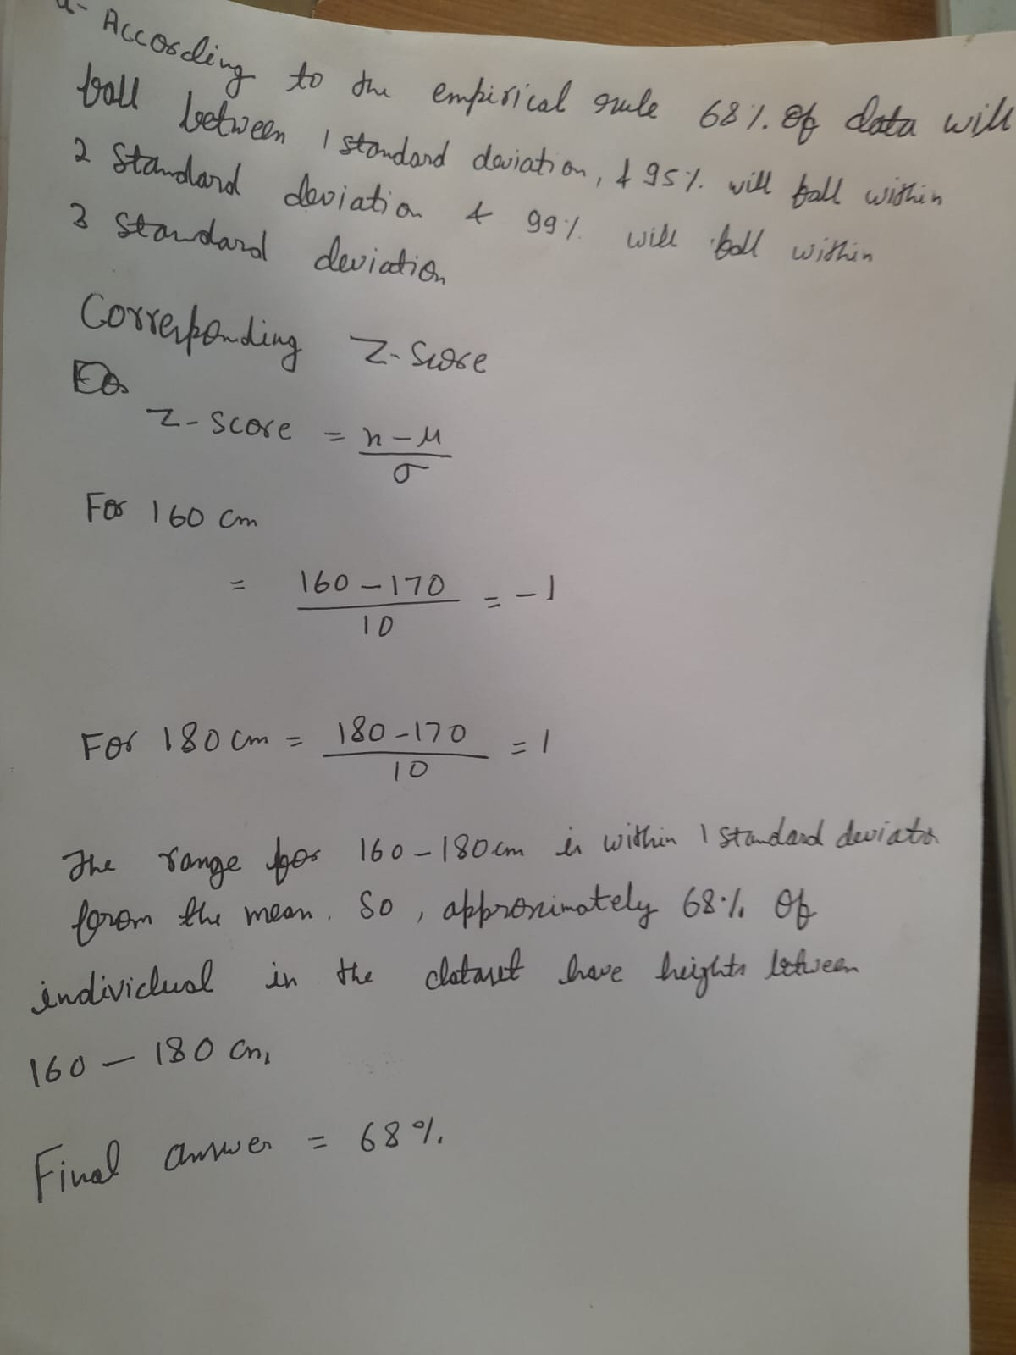

**b)** If we randomly select **100** individuals from the dataset, what is the probability

that their average height is greater than **175** cm?

**Ans:**

If we randomly select 100 individuals from the dataset, the distribution of their average height will also be approximately normal due to the **Central Limit Theorem**. We know that the mean height of the population is 170 cm with a standard deviation of 10 cm.

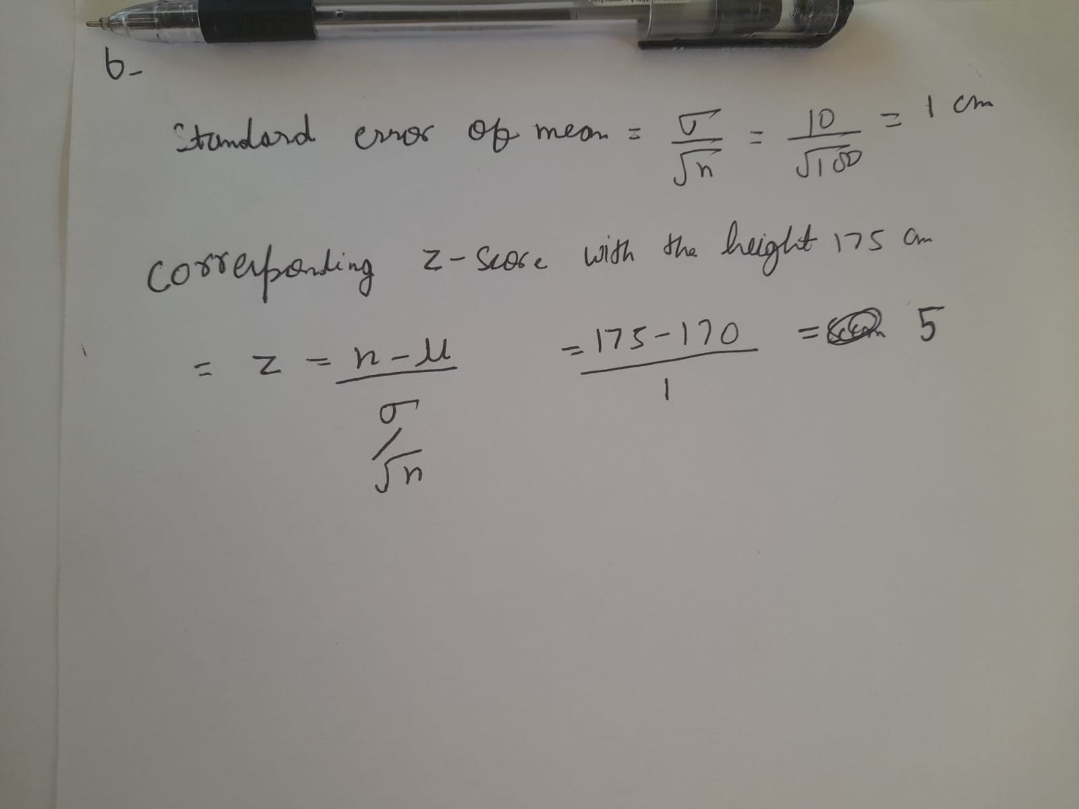

Since the normal distribution table probability of Z-score within certain range we can and the z-score 5 is very extreme we can say that probability is extremely close to 1(100%) This means that there is high chance that average height of randomly selected individual will be greater then 175 cm.

**c. Assuming the dataset follows a normal distribution, what is the z-score corresponding to a height of 185 cm?**

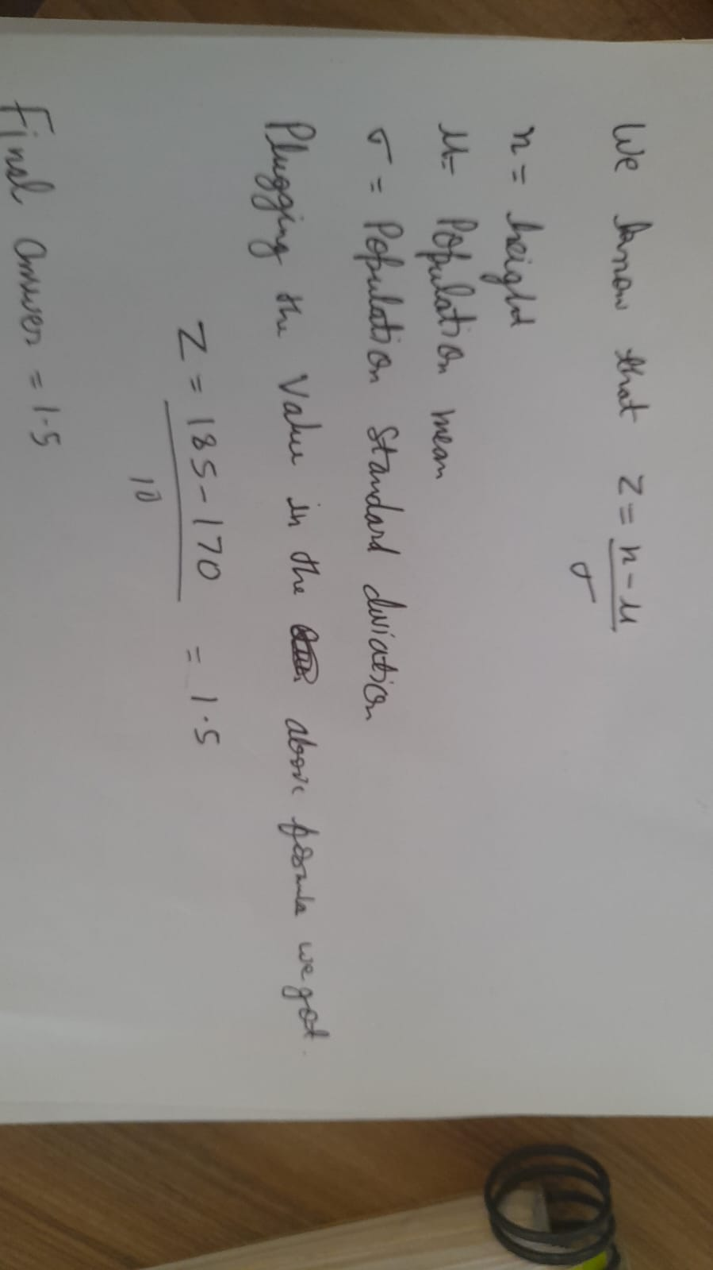

The final answer is **1.5** and the corresponding probability is **0.93319.**

**d. We know that 5% of the dataset has heights below a certain value. What is the approximate height corresponding to this threshold?**

**Ans:** If we know that 5% of the dataset has heights below a certain value, we can find the corresponding height by using the z-score and the standard normal distribution table or calculator.

The z score will be **-1.645.**

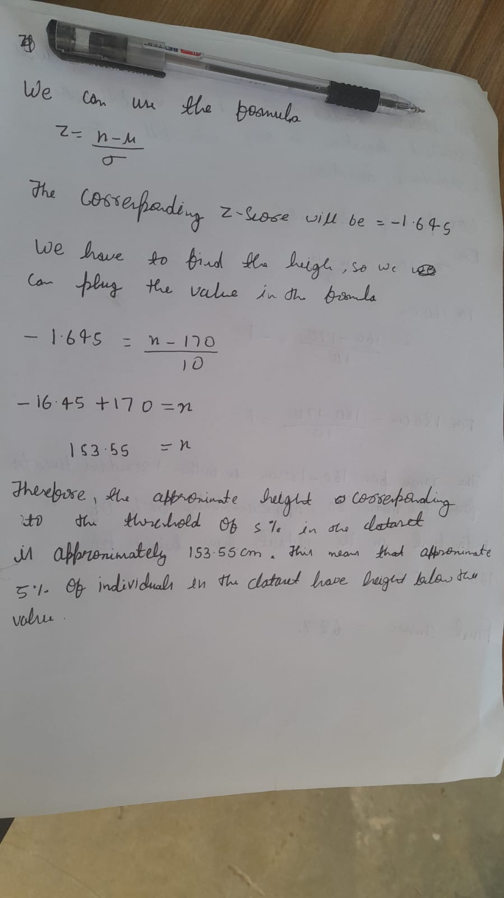**FInal answer is 153.55 cm.**

**e.** Calculate the coefficient of variation (CV) for the dataset.

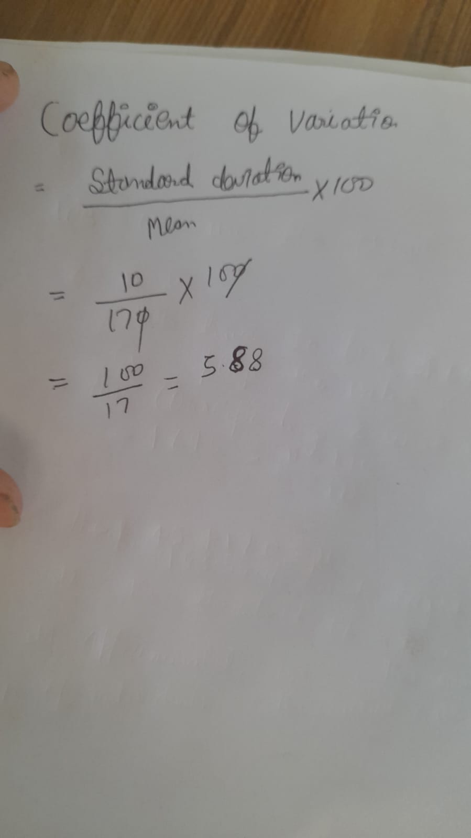The final answer is **5.88%**

**f.** Calculate the skewness of the dataset and interpret the result

Since in the question it is given that the data is approximately distributed so the skewness will be **0** or approximately equals to **0.**

It means that height is relatively distributed around the mean.

**Q-3.**

Consider the ‘Blood Pressure Before’ and ‘Blood Pressure After’ columns from the data and calculate the following

**a.** Measure the dispersion in both and interpret the results.

On calculating the value of dispersion in excel we found

To mesure dispersion we can calculate range, standard deviation and variance

**Dispersion of** **Blood Pressure Before**

| Range | 28 |
| --- | --- |
| Standard Deviation | 6.565203729 |
| Variance | 43.53727273 |
| Mean | 133.91 |

**Dispersion of Blood Pressure After**

| Range | 23 |
| --- | --- |
| Standard Deviation | 6.85349 |
| Variance | 47.4448 |
| Mean | 128.36 |

**Range:** In both case , the range provide the total spread of data . A higher range indicates a wider dispersion, suggesting greater variability between minimum and maximum values.

**Standard deviation**:This measure the overall spread of the data points.Higher value indicate greater dispersion.

**Final interpretation:**

In above case standard deviation is almost same , so we can say that spread of the data is similar both the cases.The range is relatively closer to each other.

**b. Calculate mean and 5% confidence interval and plot it in a graph**

**Mean of Blood pressure before=133.91**

**Mean of Blood pressure after=128.36**

**Confidence Interval of blood pressure before=( 132.62.135.19576)**

**Confidence Interval of blood pressure after=( 127.0174,129.7026)**

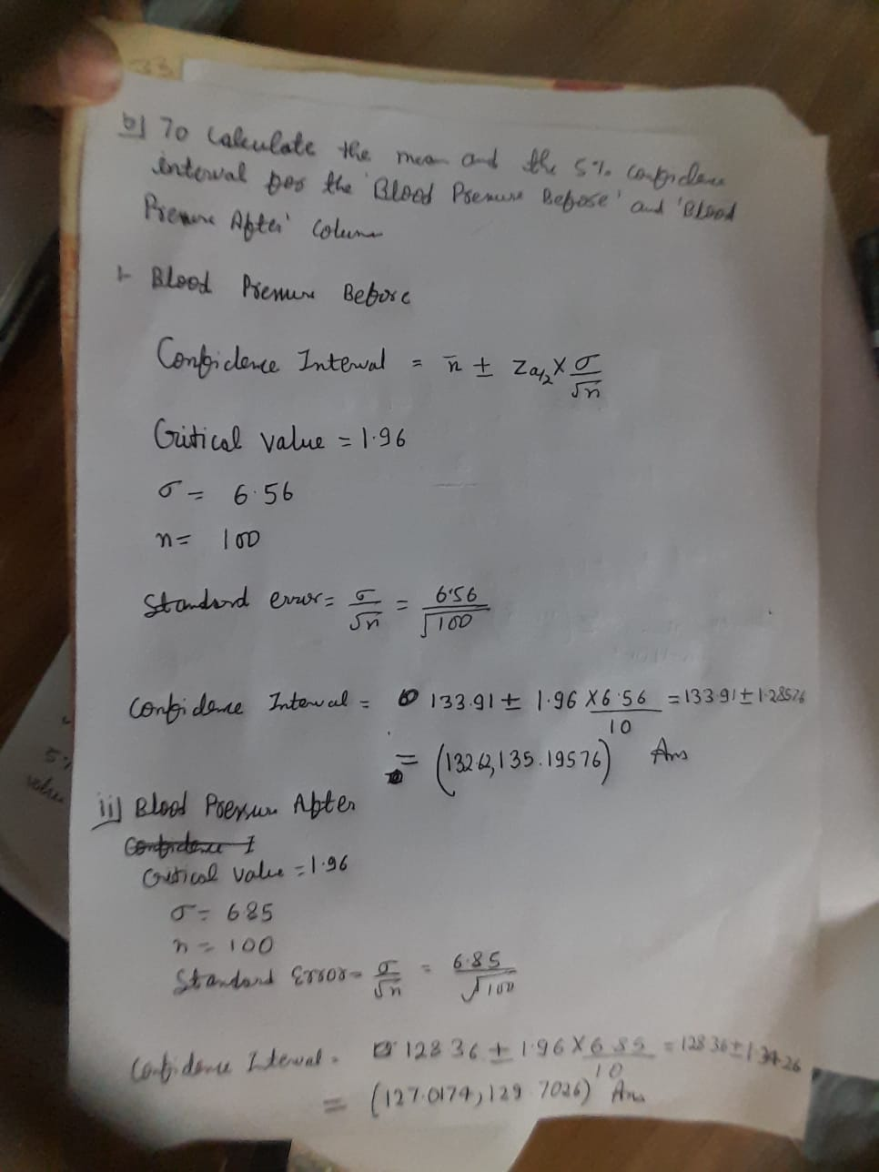

**c**. Calculate the Mean absolute deviation and Standard deviation and interpret

the results.

Mean absolute deviation blood pressure before:**132.583448**

Mean absolute deviation blood pressure after:**127.175065**

Standard deviation blood pressure before:**6.565203729**

Standard deviation blood pressure after:**6.853495459**

**As we can see from the standard deviation there is not much difference , it means that spread is nearly same before and after the blood pressure is measured.**

**The MAD after the blood pressure is measured (127.175065) is slightly lower than the MAD before the measurement (132.583448). This suggests that, on average, the individual measurements exhibit less deviation from the mean value after the blood pressure is measured compared to before.**

**d. Calculate the correlation coefficient and check the significance of it at 1% level**

**of significance.**

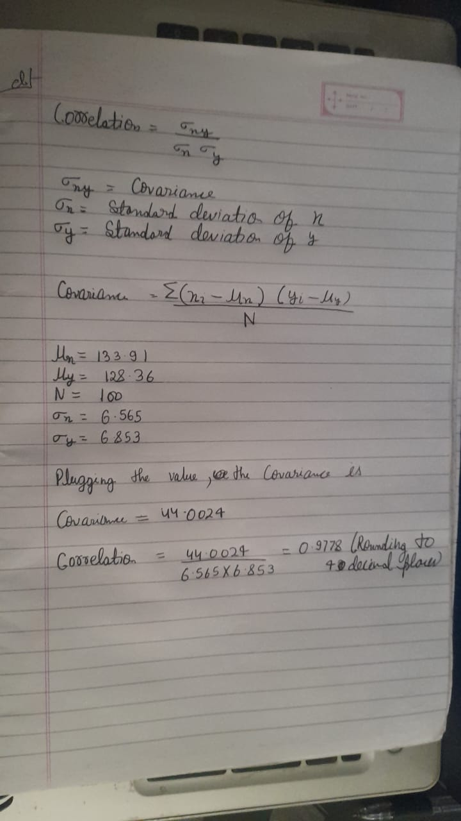**Significance Test: To check the significance of the correlation coefficient at a 1% level of significance, We can use the TTEST function.**

**Null Hypothesis: There is a no significant correlation between the 'Blood Pressure Before' and 'Blood Pressure After'**

**Alternative Hypothesis: There is significant correlation between the ‘Blood Pressure Before’ ANd ‘Blood Pressure After’.**

**Conclusion:**

**On using the TTTEST function in colab we found the p value is 0 which means that there is significant correlation between ‘Blood Pressure Before’ And ‘Blood Pressure After’ the measurement.**

**Q-4. A group of 20 friends decide to play a game in which they each write a number between 1 and 20 on a slip of paper and put it into a hat. They then draw one slip of paper at random. What is the probability that the number on the slip of paper is a perfect square (i.e., 1, 4, 9, or 16)?**

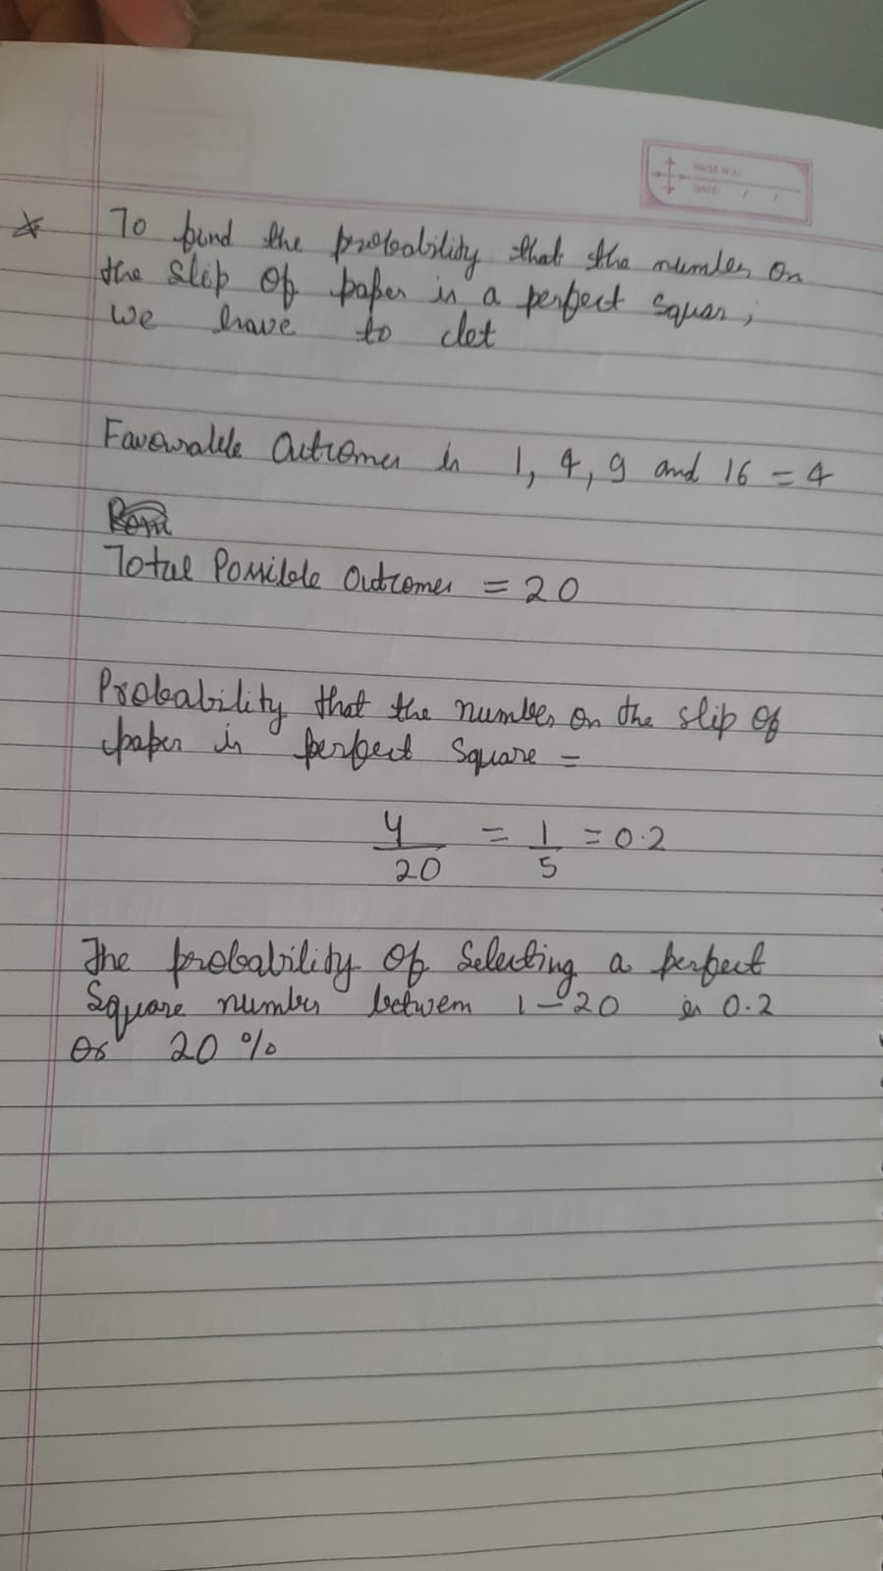

**Q-5. A certain city has two taxi companies: Company A has 80% of the taxis and Company B has 20% of the taxis. Company A's taxis have a 95% success rate for picking up passengers on time, while Company B's taxis have a 90% success rate. If a randomly selected taxi is late, what is the probability that it belongs to Company A?**

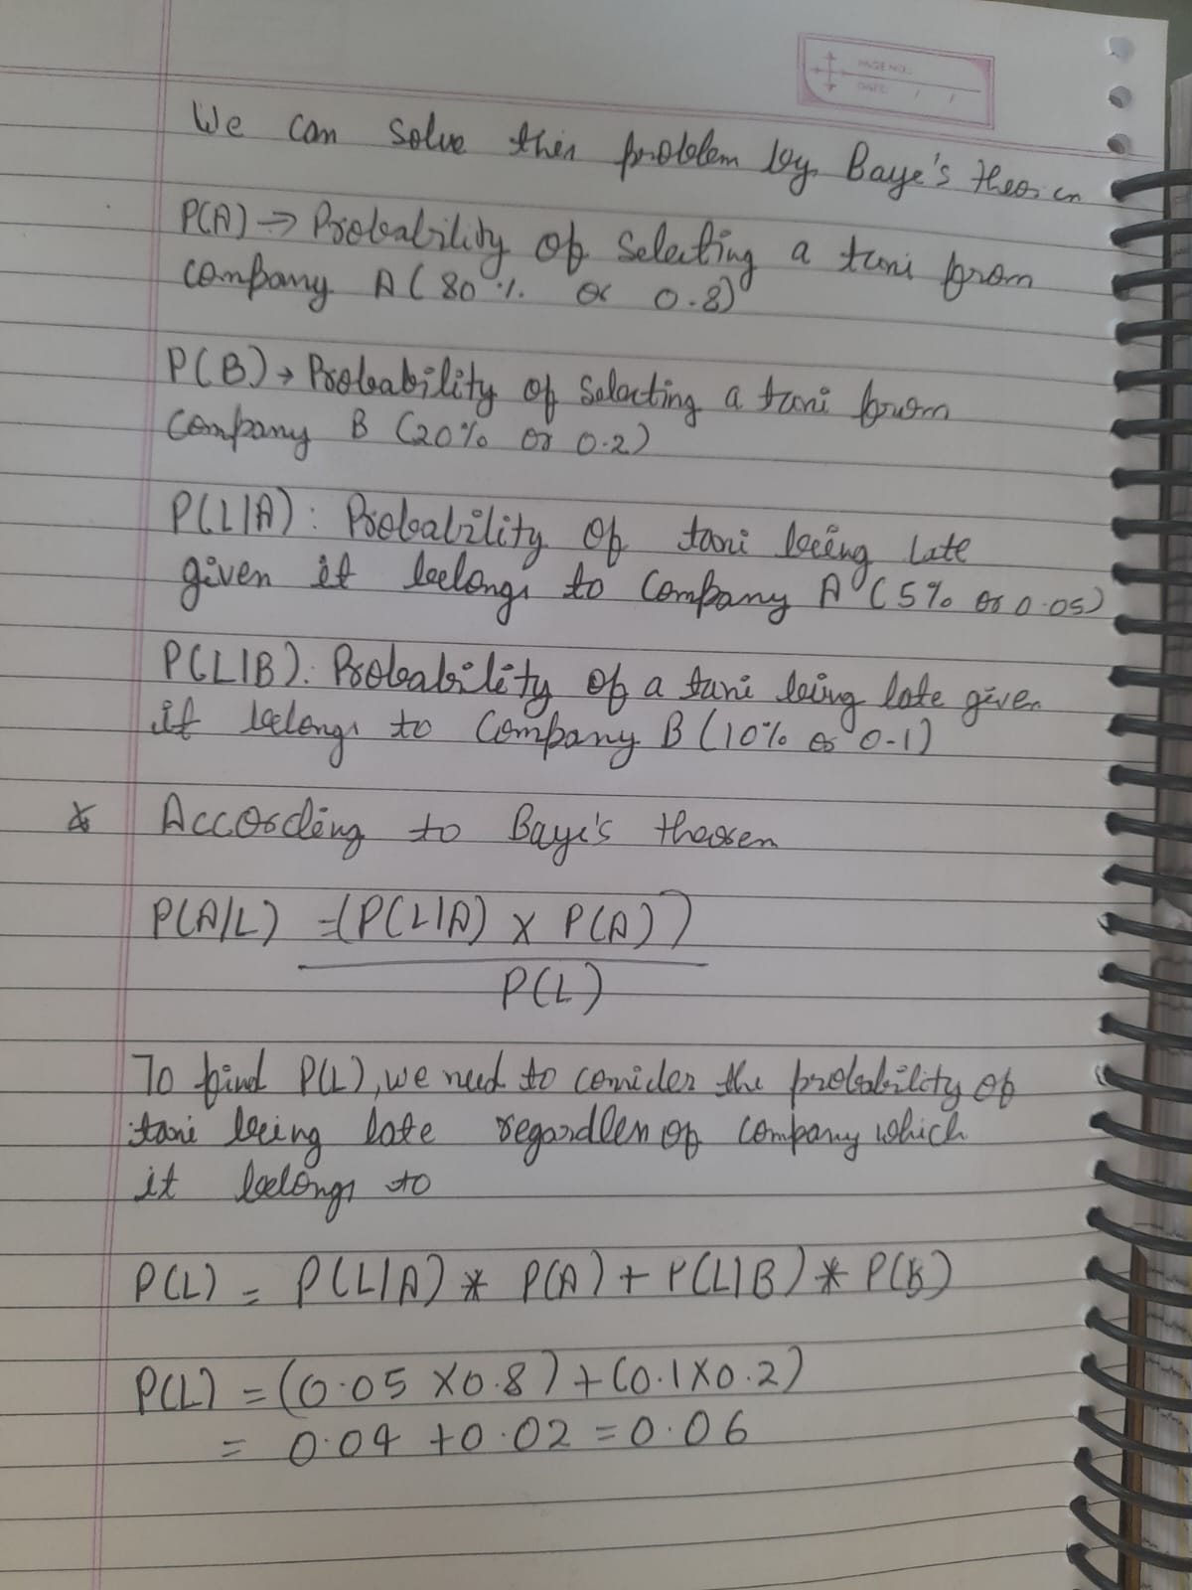

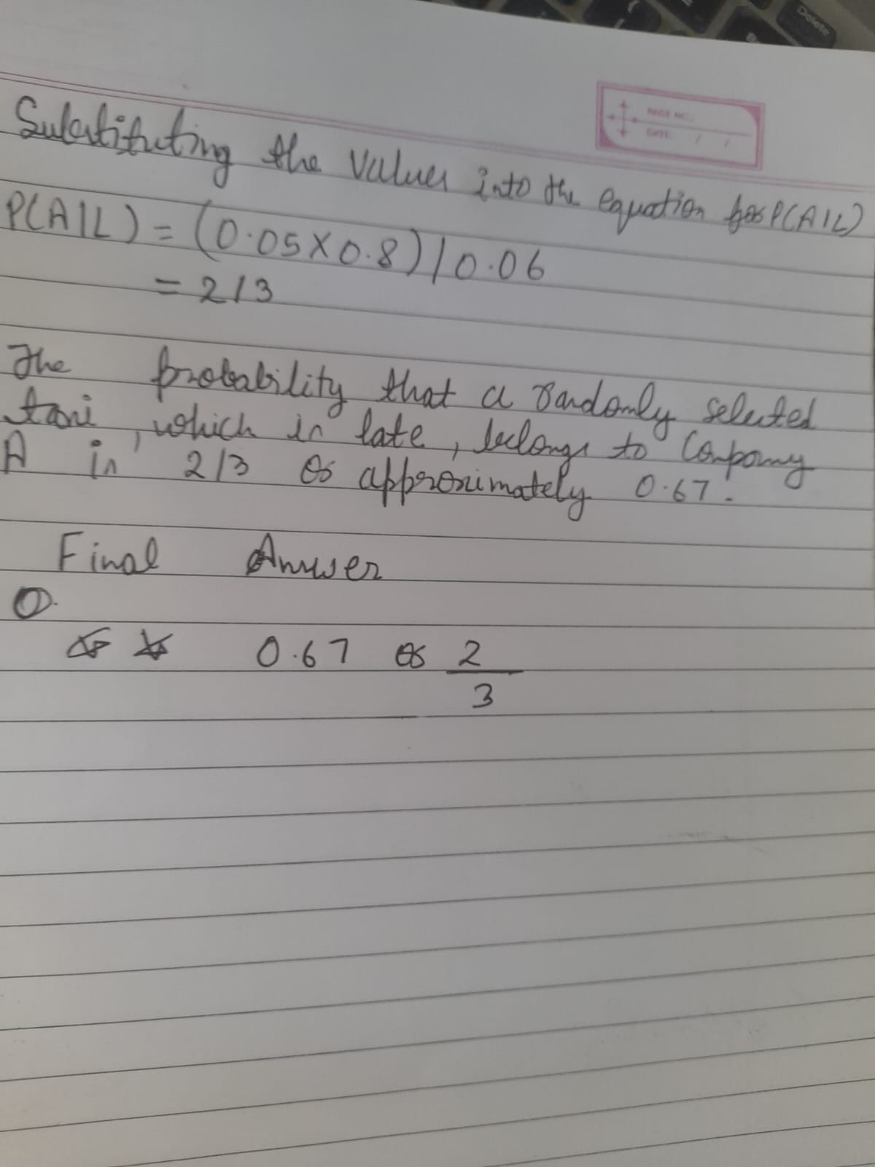

**Answer. 6 Statistics**

[**https://github.com/shiva4778/Ineuron_ppt_assignment/blob/main/Statistics_6.ipynb**](https://github.com/shiva4778/Ineuron_ppt_assignment/blob/main/Statistics_6.ipynb)

**Answer. 8 Statistics**

[**https://github.com/shiva4778/Ineuron_ppt_assignment/blob/main/Statistics_8.ipynb**](https://github.com/shiva4778/Ineuron_ppt_assignment/blob/main/Statistics_8.ipynb)

**Answer. 9 Statistics**

[**https://github.com/shiva4778/Ineuron_ppt_assignment/blob/main/Statistics_9.ipynb**](https://github.com/shiva4778/Ineuron_ppt_assignment/blob/main/Statistics_9.ipynb)

**Answer. 10 Statistics**

[**https://github.com/shiva4778/Ineuron_ppt_assignment/blob/main/Statistics_10.ipynb**](https://github.com/shiva4778/Ineuron_ppt_assignment/blob/main/Statistics_10.ipynb)

**Answer. 11 Statistics**

[**https://github.com/shiva4778/Ineuron_ppt_assignment/blob/main/Statistics_11.ipynb**](https://github.com/shiva4778/Ineuron_ppt_assignment/blob/main/Statistics_11.ipynb)

**Answer. 12 Statistics**

[**https://github.com/shiva4778/Ineuron_ppt_assignment/blob/main/Statistics_12.ipynb**](https://github.com/shiva4778/Ineuron_ppt_assignment/blob/main/Statistics_12.ipynb)

**Machine learning**

**Answer. 2 Machine learning** [**https://github.com/shiva4778/instagram**](https://github.com/shiva4778/instagram)

**Answer. 4 Machine learning** [**https://github.com/shiva4778/Ineuron_ppt_assignment/blob/main/Machine_learning_4.ipynb**](https://github.com/shiva4778/Ineuron_ppt_assignment/blob/main/Machine_learning_4.ipynb)

**Answer. 5 Machine learning**

[**https://github.com/shiva4778/Ineuron_ppt_assignment/blob/main/machine-learning-5.ipynb**](https://github.com/shiva4778/Ineuron_ppt_assignment/blob/main/machine-learning-5.ipynb)

**Answer. 6 Machine learning** [**https://github.com/shiva4778/Ineuron_ppt_assignment/blob/main/Loan_eligibility_prediction%20(2).ipynb**](https://github.com/shiva4778/Ineuron_ppt_assignment/blob/main/Loan_eligibility_prediction%20(2).ipynb)